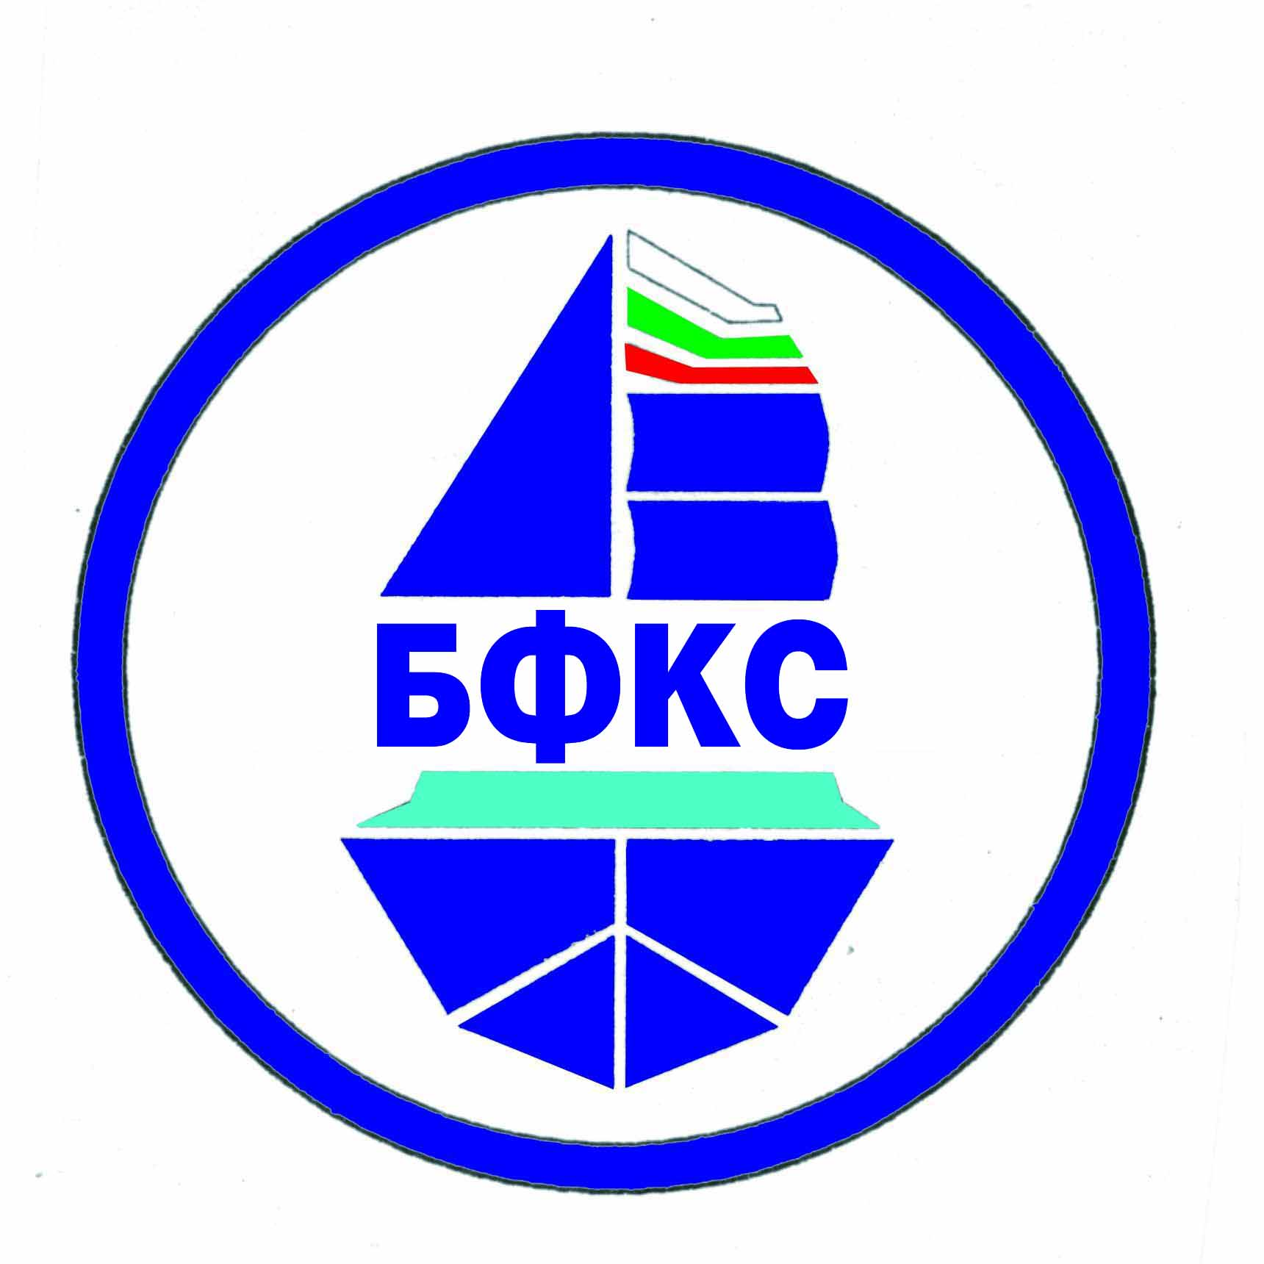

INTERNATIONAL TOURNAMENT
FOR THE CUP
"zms Ivan Marinov"
classes - M

A N N O U N C E M E N T

Organizer: Ship Model Sports Club "ZMS Ivan Marinov" - Ruse and Bulgarian Federation of Ship Modeling Sports.
Time and place: from 20 to 22.10.2023, the lake in Forest Park "Lipnik", city of Ruse.
Registration: until 13.00 on 20.10.2023 - Forest Park "Lipnik".

Classes:
Mini Eco, Eco Expert, Mini Mono, Mini Hydro, Mono 1, Hydro 1, Mono 2, Hydro 2, Team, FSR-E.

Chief judge: Josef Hristov - Bulgaria.

Training opportunity: Before the race and after the regular starts.
Regulations: The 2020 NAVIGA Regulations.
Conditions for participation: -
• Certified membership in a club and federation member of NAVIGA for 2023;
• Juniors - up to the age of 18 in 2023;
• Competitors with irregular documents will not be allowed to participate;
• Participation of junior men is allowed on an equal footing;
• Each competitor can participate in several classes;
• Each contestant participates only with the model presented at registration;
• Competitors who are not members of the BFCS club pay a double fee;
• Participation with own limiters (current limiter);
• Detection of laps is done manually.
Requests for participation should be submitted by 13.10.2023, inclusive, by phone: 0888 537 059 or
email: og.marinov@model-mm.com

Start Fees:
• Senior - Euro 10 for participation + Euro 5 for each next class.
• Junior - Euro 5. No limit in the number of classes.
• protest fee: Euro 20.

Ranking and Awards:
• Diplomas and medals for the 1st to 3rd place finishers.
• "ZMS Ivan Marinov" Cup will be awarded to the team earned max point, according to:
- Gold medal - 7 points.
- Silver medal - 5 points.
- Bronze medal - 3 point.
- For each participants of a team - 1 point.

Accommodation:
In Forest Park "Lipnik"
Complex "Lipite" tel. 0895 792 959, Double room for BGN 70 per night in total per night.
Hostel at the rowing base - 088 982 0626

In Ruse:
hl City Rai - 088 820 8877, https://www.hotelcityrai.com/
Hotel Cosmos - http://www.hotelcosmos.bg/
h-l Central - 089 626 262, https://hotelcentralruse.com/
Hotel Amor - 0897 004 392, http://hotelamor.org/
Family Hotel - 082 844 497, https://family-hotel-familya-ruse.hotelmix.bg/

