5l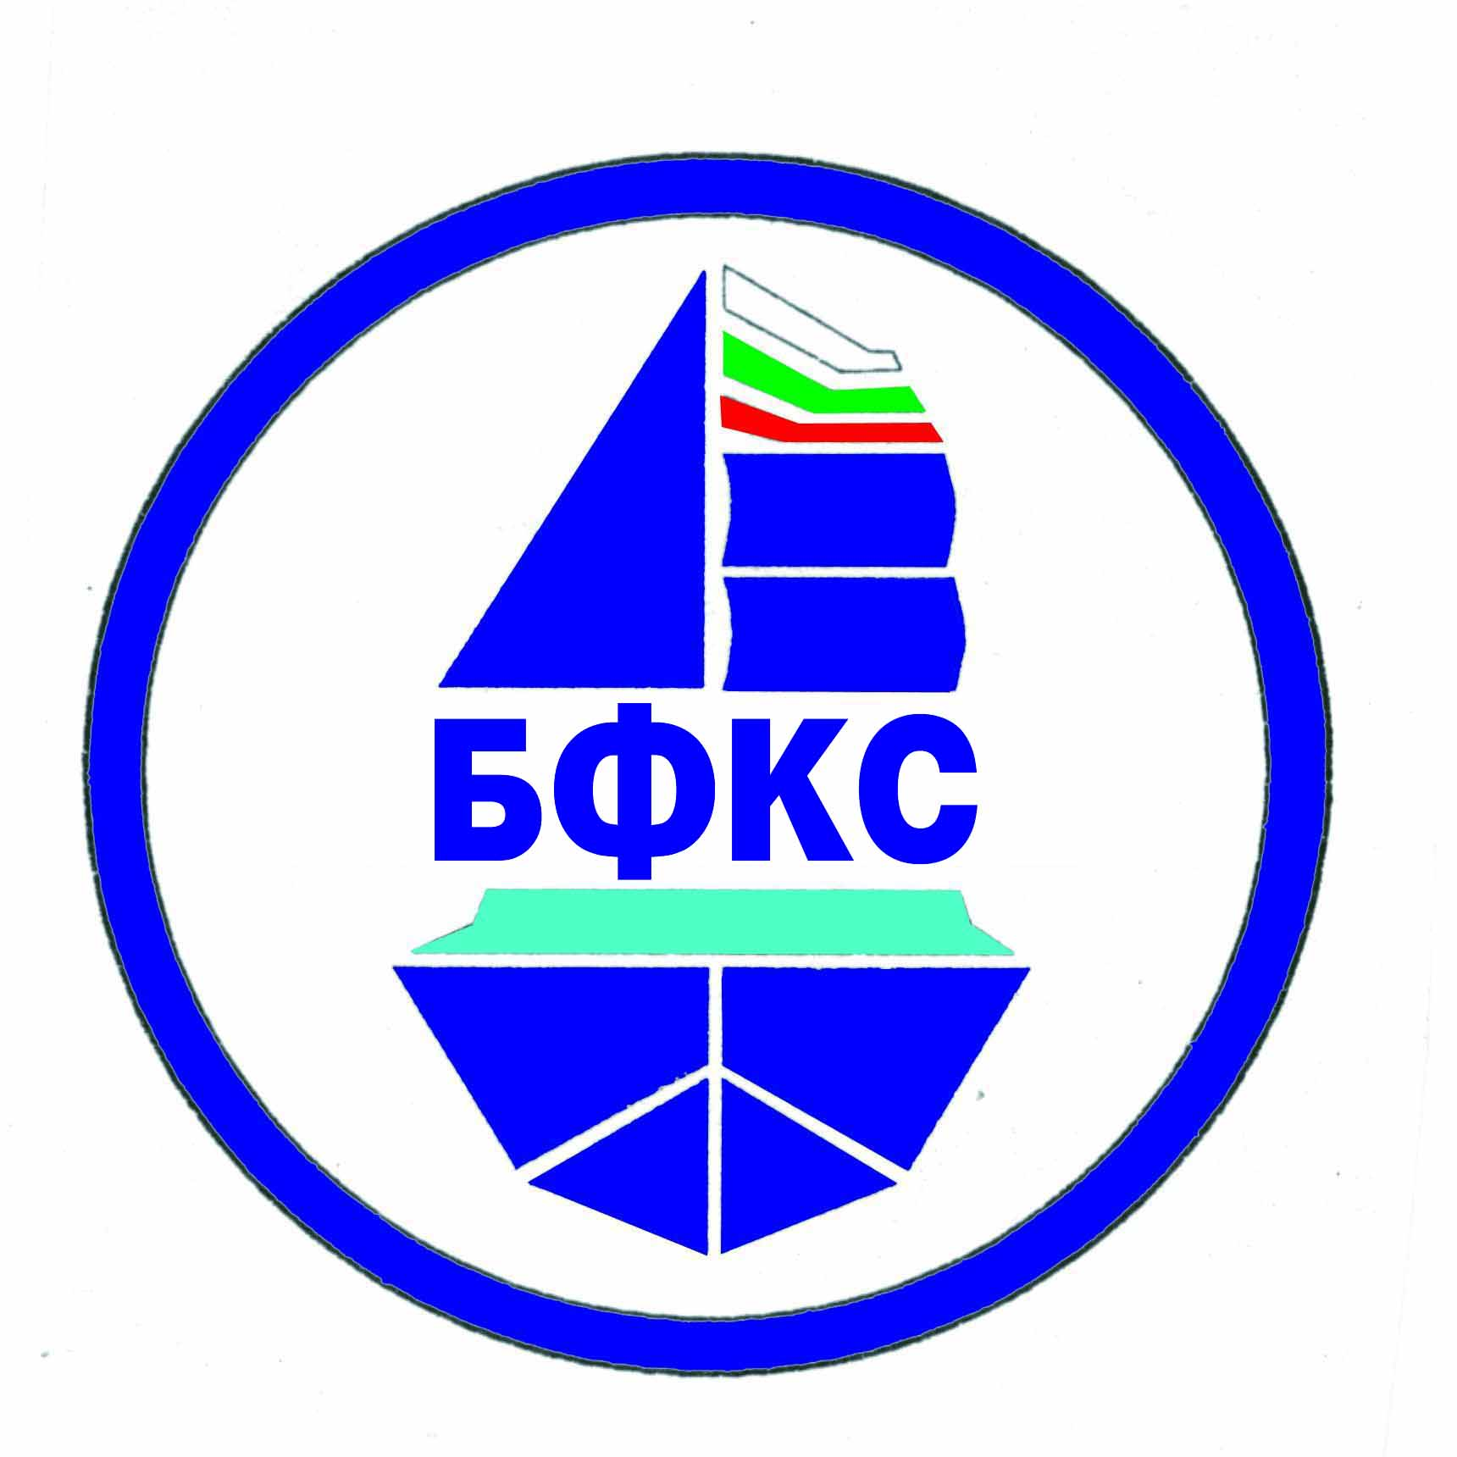 | Bulgatian Federation of Modelshipsport Bulgaria1618 Sofia,JK”Krasno selo”bl.211B,ap.32,tel+359888227837,panajotov@bfkks.com  Model yacht club - Pazardzhik  Bulgaria,4400 Pazardzhik, Gradinarska str.3, tel.+ 359878995621,myachtklub@bfkks.com | 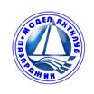

- REGULATIONS
For the holding of a Model Ship Sport International Championship for speed model ships – Classes A/B, 24-26.07.2020, Pazardzhik, the Republic of Bulgaria

Organizer: Bulgarian Federation of Model Ship Sport, Model Yacht Club - Pazardzhik
Time and place: 24-26.07.2020, Liberty Island Park, Pazardzhik
Registration: until 11.00 on 24.07.2020 at the Model Yacht Club, - Training
- 13.00 - Technical conference
- 13.30 - Opening
- 15.00 – 19.00 p.m. - starts
25.07.2020 - 09,00 – 19.00 p.m. - starts
- 20.00 - Banquet
26.07.2020 - 08.30 - 13.00 – starts
- 13.30 – Awards and championship closing ceremony
Practice possibility: Before and after the regular starts
Classes: A1, А2, A3, B1, А1Е, В1Е

Regulations: 2018 NAVIGA Regulations.
Participation requirements:
- Start fees: men- 10 Euro per model ship
- Accomodation –Trakiya Hotel - 25 Euro, for a single
room /per night/, 35 Euro for a double room /per night/;
Hebar Hotel-45 Euro for a single room, 55 Euro for a double room /per night/.
- We provide transport from Sofia Airport to Pazardzhik and
back for the sum of 20 Euro per person in one direction /by
placing a request in advance /
- Banquet - 20 Euro
Classification and awards: Cups, honorary diplomas, and medals for the participants who had won 1st to 3rd place in the championship.
Deadline for booking: until 20.06.2020
Address for booking: The Republic of Bulgaria, 4400 Pazardzhik
3 Gradinarska Str.
Dimitar Ganchev
Tel.: +35934463348, GSM: +359878995621
E-mail: myachtklub@bfkks.com

Model Yacht Club - Pazardzhik Chairman:
/D. Ganchev/

