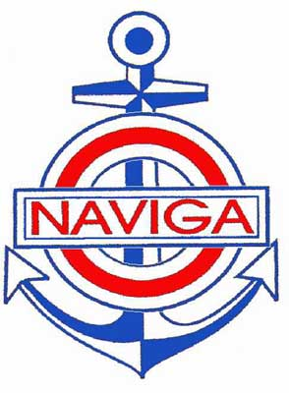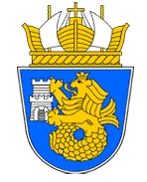

OPEN EUROPEAN COUPE "BLACK SEA"
OF MODEL SHIPS - SECTION “C”

BURGAS, REPUBLIC OF BULGARIA

02.07.2020 - 05.07.2020

ORGANISERS : Bulgarian Federation of Shipmodelsport
Maritime Cultural Center - Burgas
Municipality of Burgas - BULGARIA

LOCATION: Maritime Cultural Center - Burgas

TIME: 02.07.2020 - 05.07.2020

RULES of competition: Rules of Section С of NAVIGA 2017

COMPETITION CLASSES: C1, C2, C3, C4, C5, C6, C7, C8

Registration deadline: 15.05.2020 in letter and e-mail
office@nenovtechnic.eu, office@kvalitet-21.com
REGISTRATION: Maritime Cultural Center - Burgas
02.07.2020 from 12.00 to 18.00

Accommodation and meals: Competitors and persons accompanying them: hotels prices (nights): single - 25-30 €; double, - 20-25 €;
Meals: restaurants in town.

STARTING FEES - NAVIGA MEMBERS
Senior - EUR 15 / model
Junior - EUR 0 / model (free)

STARTING FEES - NON NAVIGA MEMBERS
- EUR 15 / model
+ EXTRA FEE EUR 15 / competitor

Bank account in Euro for
transferring the starting fees IBAN:BG13STSA93000011368935 in €
BIC Code: STSABGSF DSK Bank АD, 5, Dondukov blvd, 1000, Sofia, Bulgaria

HOTELS:

Hotel Primoretz – tel. 00359894788876
marketing@hotelprimoretz.bg , www.hotelprimoretz.bg

2. Hotel Bulgaria – 0035956 842610 , 00359888389565
www.bulgaria-hotel.com

3. Hotel Fors – 00359 56 828852
www.hotelfors-bg.com

4. Hotel Luxor – 00359847670
www.luhor-bs.com

5. Hotel Atagen – 00359 56 812218
www.hotelatagen.com

PROGRAMME OF CHAMPIONSHIP

PROGRAMME: TIME EVENT

02 JULY 12.00 - 18.00 Registration
18.00 - 18.30 Technical Conference

03 JULY 09.00 - 09.30 Opening ceremony
10.00 - 16.00 Evaluation of classes
10.00 - 18.00 Public exposition

04 JULY 09.00 - 18.00 Public exposition
09.00 - 16.00 Evaluation of classes

05 JULY 09.00 - 12.00 Public exposition
11.00 - 12.00 Awarding Ceremony
12.00 - 13.00 Return of models

