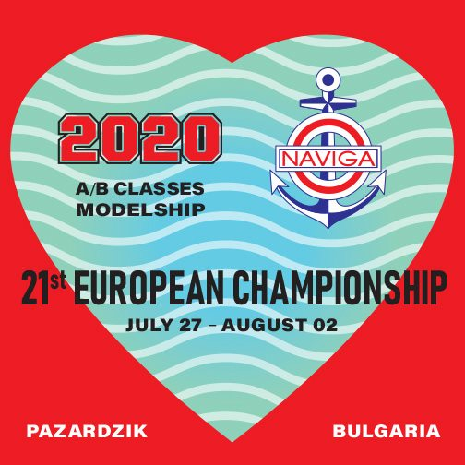

**21st European Championship of Modelshipsport for Speed**

**Model ships**

**27.07.2020 to 02.08.2020 in the town of Pazardzhik, the Republic of Bulgaria**

**Classes: A1, A2, A3, B1, A1E, B1E**

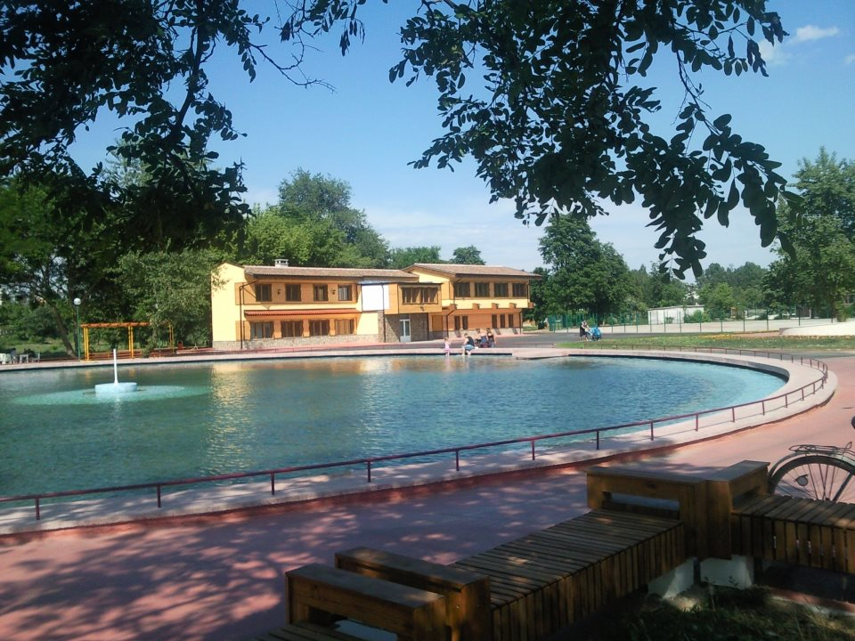

**“Liberty Island” Park, the town of Pazardzhik-（GPS: 42°10'53.1"N /24°20'04.6"E）**

**W E L C O M E F R I E N D S ! ! !**

**Model Yacht Club – Pazardzhik**

 **World Organisation for Modelshipbulding and Modelshipsport NAVIGA**

**Българска федерация по корабомоделен спорт**

**Модел яхт клуб , Община Пазарджик**

**Р Е Г Л А М Е Н Т**

за участие в 21-то Европейско първенство по корабомоделен спорт за

скоростни корабни модели – класовете „А/В” от 27.07 до 02.08.2020 г. в гр.Пазарджик Република България

|  |  |
| --- | --- |
| **Организатор** | World Organisation for Modelshipbuiling and Modelshipsport NAVIGA  Българска федерация по корабомоделен спорт  Модел яхт клуб-Пазарджик , Община Пазарджик |
| **Изпълнител** | Модел яхт клуб - Пазарджик |
| **Място** | Република България, град Пазарджик, Парк „Остров Свобода” |
| **Време за провеждане** | от 27.07 до 02.08.2020 година |
| **Главен съдия** | Svetlfmir Sdnoel -BUL |
| **Представител**  **на NAVIGA** | Hrachya Shahazizyan –Leader of Section A/B - NAVIGA |
| **Технически директор** | Димитър Ганчев -BUL  E-mail: **myachtklub@bfkks.com** |
| **Главен секретар** | Лариса Пасхалова - UKR |
| **Правилник** | **NAVIGA – 01.01.2018** |
| **Класове** | **А1, А2, А3, В1, А1Е, В1Е** |
| **Допустим брой модели от национална федерация** | Всяка страна има право до 10 участника във всеки клас. След приемането на заявките, във всеки клас трябва да има минимум **10** участника – при мъжете , а при юношите **6** участника . Юношите не трябва да са по-големи от 18 години, навършени през 2020 г. |
| **Възрастови групи** | Мъже и юноши |
| **Други изисквания** | 1.Не се допускат съдии да участват и като състезатели.  2.До **05.07.2020 г.** Изпълнителя ще уведоми всички отбори за броя на заявените спортисти във всеки отделен клас и в кои класове ще се проведат стартове, валидни за класиране в Европейското първенство. В класовете с регистрирани под **10** състезателя – при мъжете и под **6** състезателя - при юношите, няма да се присъжда титлата **Европейски шампион.**  **3.**При регистрацията , водачите на отбори да предоставят на организатора по **3 /три/** броя национални знамена с размер 1/1,5 м. и **националният химн** – записан на компакт диск или на флаш памет.  4.Състезателите в Е класовете да заявят обхвата на радиоапаратурите и номерата на кварцовете /без 2,4 DSM/ |
| **Краен срок за получаване на заявките** | **21.06.2020 г.**  Молим, освен в електронен вид, заявката да се изпрати и на хартиен носител. |
| **Потвърждаване от изпълнителя за получена заявка** | Изпълнителят ще потвърждава до 5 дни всяка получена заявка на посочен от Заявителя електронен адрес.Молим, Заявителят да посочи телефакса или пощенски адрес, ако няма електронен адрес. |
| **Най-късна дата за пристигане** | **28.07.2020 г.** |
| **Регистрация** | От 13,30 ч. до 18,00 ч. на 27.07.2020 г. и от 09,00 до 11,00 ч на 28.07.2020 г. в Модел яхт клуб-Пазарджик, парк „Остров Свобода” |
| **Техническа конференция** | На 28.07.2020 г. от 11,15 ч. в Модел яхт клуб-Пазарджик |
| **Медали, грамоти и други награди** | 1. Медали и грамоти 2. Грамоти за всички участници 3. Купа „Г. Миров” за клас А1,Купа „Ф. Стефанов” за клас А2, Купа“Вл.Суботин” за клас А3, Купа „Р. Радев” за клас В1   Купа „ Л.Лазаров“ за класовете А/В-Е |
| **Стартови такси** | За мъже – 30 Euro , за юноши – без такса / **+ 5** Euro – **застраховка -на клас/** |
| **Цена на горивото** | За А1,В1 – 3 Euro, A2 – 4 Euro, А3 – 6 Euro, А1 и В1 – 3 Еuro  **Моля, изпращайте таксите за участие, резервациите за хотела и за банкета предварително на приложената сметка** |
| **Такса за протести** | 20 Euro |
| **Адреси за изпращане на заявките** | До 21.06.2020 г. – E-mail: [panajotov@bfkks.com](mailto:panajotov@bfkks.com)  Postal address: Recipient: Kolya Panayotov, 211, Krasno Selo Housing Estate, Entrance 2, flat 32, the city of Sofia 1618, Bulgaria  Пощенски адрес: До 19.07.2020 г. – на Е-mail: [myachtklub@bfkks.com](mailto:myachtklub@bfkks.com)  Пощенски адрес: България, 4400 Пазарджик, ул.”Градинарска” 3,  Димитър Ганчев, тел.+35934463348, GSM+359878995621 |
| **Банкет** | На 31.07.2020 г. от 20,00 ч. с цена 20 Euro за състезатели, водачи на отбори и  придружаващи лица. |
| **Банкова сметка в евро за превеждане на стартовите такси, гориво и банкет** | **DSK BANK - BULGARIA**  **IBAN: BG42STSA93000025916570**  **BIC: STSABGSF**  **MODEL YACHT CLUB-PAZARZHIK** |
| **Настаняване и хранене** | ***Хотел „Тракия”,тел:+35934466006, E-mail:trakijaburo@abv.bg  www.Hotel-Trakia.domino.bg   * стая с 1 легло: 25 Euro , със закуска * стая с 2 легла: 35 Euro , със закуска * апартамент : 45 Euro , със закуска * вечеря:+8 Euro - на човек   **\*\*\*\*Х**отел „Хебър”, тел:+35934990000,E-mail:reservation@grandhotelhebar.net  www.grandhotelhebar.net   * стая с 1 легло: 40 Euro, * стая с 2 легла: 55 Euro, апартамент: 90 Euro /за трима/ * вечеря: + 10 Euro , на човек * в цената са включени: закуска,паркинг, застраховка,   интернет, сауна, фитнес  **При предварителна информация и заявка е възможно организиране на транспорт от летище София до гр.Пазарджик и обратно.** |
| **Краен срок за актуализация на заявката, относно настаняването** | **19.07.2020 г.** |

**Балгарска федерация по корабомоделен спорт** **Модел яхт клуб – Пазарджик**

**Председател: Председател:**

**/Е.Генов/ /Д.Ганчев/**

**World Organisation for Modelshipbulding and Modelshipspoirt NAVIGA**

**Bulgarian Federation of Modelsipsport , Model yacht club - Pazardzhik**

**REGULATIONS**

For Participation in the 21-st European Championship of Modelshipsport for Speed Modelships – Classes A/B

From 27 July to 02 August 2020 in the town of Pazardzhik, the Republic of Bulgaria

|  |  |  |  |
| --- | --- | --- | --- |
| **Organizer** | | World Organisation for Modelshipbuilding and Modelshipsport NAVIGA  Bulgarian Federation of Modelshipsport  Municipality Pazardzhik | |
| **Executor** | | Model Yacht Club - Pazardzhik | |
| **Place** | | “Liberty Island” Park, the town of Pazardzhik, the Republic of Bulgaria | |
| **Time of Holding** | | From 27.07.2020 to 02.08.2020 | |
| **Chief Justice** | | Svetlomir Sandev- BUL | |
| **Representative of NAVIGA** | | Hrachya Shahazizyan – Leader of Section A/B – NAVIGA | |
| **Technical Director** | | Dimitar Ganchev - BUL  E-mail: myachtklub@bfkks.com | |
| **Chief Secretary** | | Larysa Paskhalova - UKR | |
| **Rules** | | **NAVIGA – 01.01.2018** | |
| **Classes** | | **A1, A2, A3, B1, A1E, B1E** | |
| **Allowed number of models from a national federation** | | Each country has the right of 10 participants in a class, plus the European champion from 2020. After accepting the applications, there must be at least **10** participants in each class of the senior and **6** participants of the junior. The juniors must not be older than 18 in 2020. | |
| **Age Groups** | | Man and youths | |
| **Other Requirements** | | 1. Judges are not allowed to participate as competitors. 2. By **12.07.2020** the Executor will inform all teams about the number of the registered competitors in each class and about in which classes there will be starts held valid for classification for the European Championship. In classes where there are fewer competitors than **10** for the senior and fewer than **6** for the junior the title **European Champion** will not be awarded. 3. At registration, the leader of the teams have to provide the organizer with **3 / three/** national flags in the size of 1/1.50 m and **the national anthem** recorded on a compact disk or a flash memory. 4. The competitors in E classes have to provide the range of their radio appliances and the numbers of the quartzes, without any 2.4 MHz /DSM/. | |
| **Deadline for receiving applications** | | **21.06.2020**  We would like you to send as your application both electronically and on paper. | |
| **Confirmation of received application by the executor** | | The executor will confirm each application within 5 days at an e-mail mentioned by the applicant. We would like you to provide us with fax number or postal address if you do not have an e-mail. | |
| **Latest possible date for arrival** | | **28.07.2020** | |
| 5lЕМБЛЕМА-БФКС -12% | | **Bulgatian Federation of Modelshipsport** Bulgaria1618 Sofia,JK”Krasno selo”bl.211B,ap.32,tel+359888227837,panajotov@bfkks.com  **Model yacht club - Pazardzhik**  Bulgaria,4400 Pazardzhik, Gradinarska str.3, tel.+ 359878995621,myachtklub@bfkks.com | | ЕМБЛЕМА-КЛУБА-намалена | |

- REGULATIONS

For the holding of a Model Ship Sport International Championship for speed model ships – Classes A/B, 24-26.07.2020, Pazardzhik, the Republic of Bulgaria

Organizer: Bulgarian Federation of Model Ship Sport,Model Yacht Club - Pazardzhik

Time and place: 24-26.07.2020, Liberty Island Park, Pazardzhik

Registration: until 11.00 on 24.07.2020 at the Model Yacht Club, - Training

- 13.00 - Technical conference

- 13.30 - Opening

- 15.00 – 19.00 p.m. - starts

25.07.2020 - 09,00 – 19.00 p.m. - starts

- 20.00 - Banquet

26.07.2020 - 08.30 - 13.00 – starts

- 13.30 – Awards and championship closing ceremony

Practice possibility: Before and after the regular starts

Classes: A1, А2, A3, B1, А1Е, В1Е

Regulations: 2018 NAVIGA Regulations.

Participation requirements:

- Start fees: men- 10 Euro per model ship

- Accomodation –Trakiya Hotel - 25 Euro, for a single

room /per night/, 35 Euro for a double room /per night/;

Hebar Hotel-45 Euro for a single room, 55 Euro for a double room /per night/.

- We provide transport from Sofia Airport to Pazardzhik and

back for the sum of 20 Euro per person in one direction /by

placing a request in advance /

- Banquet - 20 Euro

Classification and awards: Cups, honorary diplomas, and medals for the participants who had won 1st to 3rd place in the championship.

Deadline for booking: until 20.06.2020

Address for booking: The Republic of Bulgaria, 4400 Pazardzhik

3 Gradinarska Str.

Dimitar Ganchev

Tel.: +35934463348, GSM: +359878995621

E-mail: [myachtklub@bfkks.com](mailto:myachtklub@bfkks.com)

**Model Yacht Club - Pazardzhik** Chairman:

/**D. Ganchev**/

|  |  |
| --- | --- |
| **Registration** | From 13:30 to 18:00 on 27.07.2020 and from 09:00 to 12:00 on 28.07.2020 at Model Yacht Club – Pazardzhik, “Liberty Island” Park |
| **Technical Conference** | On 28.07.2020 at 13:30 at Model Yacht Club – Pazardzhik |
| **Medals, Honorary Diplomas and Other Prizes** | 1.Medals and honorary diplomas; Diplomas for all  2.“Georgi Mirov” Bowl for class A1, “Filip Stefanov” Bowl for class A2, “Vladislav Subotin” Bowl for class A3, “Radi Radev” Bowl for class B1, „Lazar Lazarov” of updates in classes A/B-E |
| **Initial Fees** | For Seniors – 30 Euro, Juniors – /no fee /,+**5** Euro – **insurance**/ |
| **Price of Fuel** | For A1, B1 – 3 Euro, A2 – 4 Euro, A3 – 6 Euro ,B1E, A1E-3 Euro  **Please, send the fees for participation, booking the hotel and for the reception in advance to the enclosed bank account.** |
| **Fee for Protests** | 20 Euro |
| **Addresses for Sending the Applications** | By 21.06.2020 – at E-mail: [panajotov@bfkks.com](mailto:panajotov@bfkks.com)  Postal address: Recipient: Kolya Panayotov, 211, Krasno Selo Housing Estate, Entrance 2, flat 32, the city of Sofia 1618, Bulgaria  Tel.: +3598564147, Mobile phone: +359888227837  From 19.07.2020 – at E-mail: [myachtklub@bfkks.com](mailto:myachtklub@bfkks.com)  Postal address: Recipient: Dimitar Ganchev,3, Gradinarska Str, the town of Pazardzhik 4400, Bulgaria  Tel.: +35934463348, Mobile phone: +359878995621 |
| **Banquet** | On 31.07.2020 at 20:00, a price of 20 Euro for competitors, leaders of teams and accompanying people. |
| **Bank Account in Euro for sending the initial fees, the fees for fuel and the reception.** | **DSK BANK - BULGARIA**  **IBAN: BG42STSA93000025916570**  **BIC: STSABGSF**  **MODEL YACHT CLUB-PAZARZHIK** |
| **Accommodation and Food** | *** Trakiya Hotel, Tel.: +35934446006, E-mail: [trakijaburo@abv.bg](mailto:trakijaburo@abv.bg). [www.Hotel-Trakia.domino.bg](http://www.Hotel-Trakia.domino.bg)   * Single room: 25 Euro * Double room: 35 Euro * Suite : 45 Euro **** Hebar Hotel, Tel.: +35934990000, E-mail: [reservation@grandhotelhebar.net](mailto:reservation@grandhotelhebar.net), [www.grandhotelhebar.net](http://www.grandhotelhebar.net) * Single room: 40 Euro * Double room:50 Euro * Suite: 90 Euro /for three people/   The prides includes breakfast, parking, insurance, internet  **The transport from Sofia Airport to the town of Pazardzhik is possible to be organized if there is a request and order in advance from your side.** |
| **Deadline for updating your booking with regard to the accommodation:** | **19.07.2020** |

**Bulgarian Federation of Modelshipsport Model Yacht Club – Pazardzhik**

**Chairman: Chairman:**

**/E. Genov/ /D. Ganchev/**

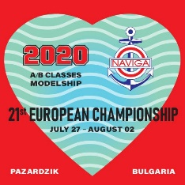**Program of the XXI European Championship**

**for tethered hydroplanes class A/B – Pazardzhik 27.07-02.08.2020**

27.07.20 - Monday

13.30 – 18.00 - Registration - on the lake

08.00 - 20.00 - Training

28.07.20 - Tuesday

09.00 – 12.00 - Registration - on the lake

13.00 - Judges conference - on the lake

13.30 - Тechnical conference - on the lake

08.00 - 14.00 - Training

14.30 – 16.30 - А3 first attempt

16.30 - 17.30 - А2 first attempt -

17.30 – 18.00 - Оpenning ceremony

29.07.20 - Wednesday

08.30 – 10.30 - А1,A1E first attempt

10.30 – 12.30 - В1 first attempt

14.30 – 15.00 - Lunch

15.00 – 16.00 - B1E first attempt

16.00 – 17.00 - А2 second attempt

17.00 – 18.30 - А3 second attempt

30.07.20 - Thursday

08.30 – 10.30 - В1,B1E second attempt

10.30 – 12.00 - A1 second attempt

12.30 – 13.30 - Lunch

14.30 – 15.30 - A1junior,A1E second attempt

15.30 – 17.30 - A3 third attempt

17.30 – 18.30 - А2 third attempt

31.07.20 – Friday

08.30 – 10.30 - A1,A1E third attempt

10.30 – 12.30 - В1 third attempt

12.30 – 13.30 - Lunch

14.30 – 15.30 - B1E third attempt

15.30 – 16.30 - A2 fourth attempt

16.30 – 18.30 - A3 fourth attempt

21,00 - Banquet

01.08.20 - Saturday

09.00 – 11.00 - B1,B1E fourth attempt

11.00 – 12.30 - A1 fourth attempt

12.30 – 13.30 - Lunch

14.30 – 15.30 - A1junior,A1E fourth attempt

15.30 – 17.30 - A3 fifth attempt

17.30 – 18.30 - А2 fifth attempt

02.08.20 – Sunday

08.30 – 10.30 - A1,A1E fifth attempt

10.30 – 13.00 - B1,B1E fifth attempt

16.30 - Closing ceremony

 **World Organisation for Modelshipbulding and Modelshipsport NAVIGA**

**Bulgarian Federation of Modelsipsport**

**APPLICATION**

By ………………………………………………

*/the name of the applying national federation/*

For Participation in the 21 European championship of Model Ship Sport, Classes A/B

From 27 July- 02 August 2020 in the town of Pazardzhik, the Republic of Bulgaria

Dear Sports Friends,

Our federation will take part in the 20th European championship for Speed Model Ships, Classes A/B with the following competitors:

|  |  |  |  |  |  |  |
| --- | --- | --- | --- | --- | --- | --- |
| No | First name and surname of the competitor | License number | **Date of Birth** | Senior or Junior | Classes | Competitor, Leader, Accompanying Person |
| … | …………………… | ……. | ……… | ……….. | ……… | …………. |
| … | …………………… | ……. | ……… | ……….. | ……… | …………. |

*(Please, continue the table with the number of lines you need)*

**DATA NECESSARY FOR ISSUING ENTRANCE VISAS**

|  |  |  |  |  |  |
| --- | --- | --- | --- | --- | --- |
| No | First name and Surname | **Date and Place of Birth** | Passport No | Expiry Date of the Passport | Function: Competitor, Coach, Judge |
| 1. | ………………………….. |  |  |  |  |
| 2. | …………………………. |  |  |  |  |

Possible date and time of arrival and departure:

* by car: …………..
* by train:…………..
* by plane:…………………

/On preliminary order, the Organizer will provide transport from Sofia Airport to city of Pazardzhik and back. The price for transport in one direction is 25 eur per person (up to 3 persons) and 20 euro per person (above 3 persons)./

**1. We would like to book rooms at hotels for the following dates:**

|  |  |  |  |  |  |  |  |  |  |  |  |  |
| --- | --- | --- | --- | --- | --- | --- | --- | --- | --- | --- | --- | --- |
| Hotel | Room with beds | Number of rooms | Price per room in € | 26.07 | 27.07 | 28.07 | 29.07 | 30.07 | 31.07 | 01.08 | 02.08 | 03.08 |
|  |  |  |  |  |  |  |  |  |  |  |  |  |
|  |  |  |  |  |  |  |  |  |  |  |  |  |
|  |  |  |  |  |  |  |  |  |  |  |  |  |

**Total: ……………….. Euro**

**2. Reception:**

Number of People:………….. x 20 Euro = ………… Euro

**3.Initial Fees:**

- Junior – \no fee\………number of classes = ……… Euro / + 5 Euro – insurance /for class/

- Senior – 30 Euro x ………number of classes = ………Euro / + 5 Euro - insurance /for class/

1. **Price of the Fuel**

A1;B1 – 3 Euro x ______________ = _______________________ Euro

A2 – 4 Euro x ______________ = _______________________ Euro

A3 – 6 Euro x ______________ = _______________________ Euro

A1E,B1E- 4 Euro x _______________ = ______________________ Euro

**Total Amount: _________________________________________ Euro**

**Booking of the hotels will be done only if the fees are paid through bank transfer in advance.**

**It is advisable to make the application for the whole team. If there are any competitors who have been declared for participation but do not come, the leader of the team pays the initial fees for ordered models.**

**Bank Account:**

**DSK BANK - BULGARIA**

**IBAN: BG42STSA93000025916570**

**BIC: STSABGSF**

**MODEL YACHT CLUB-PAZARZHIK**

We expect to receive the confirmation of this Application at the following address:

E-mail: myachtklub@bfkks.com

Postal address: Recipient: Dimitar Gdnchev, Gradinarska str.3,

4400, Pazardzhik, Bulgaria

Date: …………………. On behalf of ……………………… Federation:

…………………………………………………...

*/Surname, Signature, Seal/*