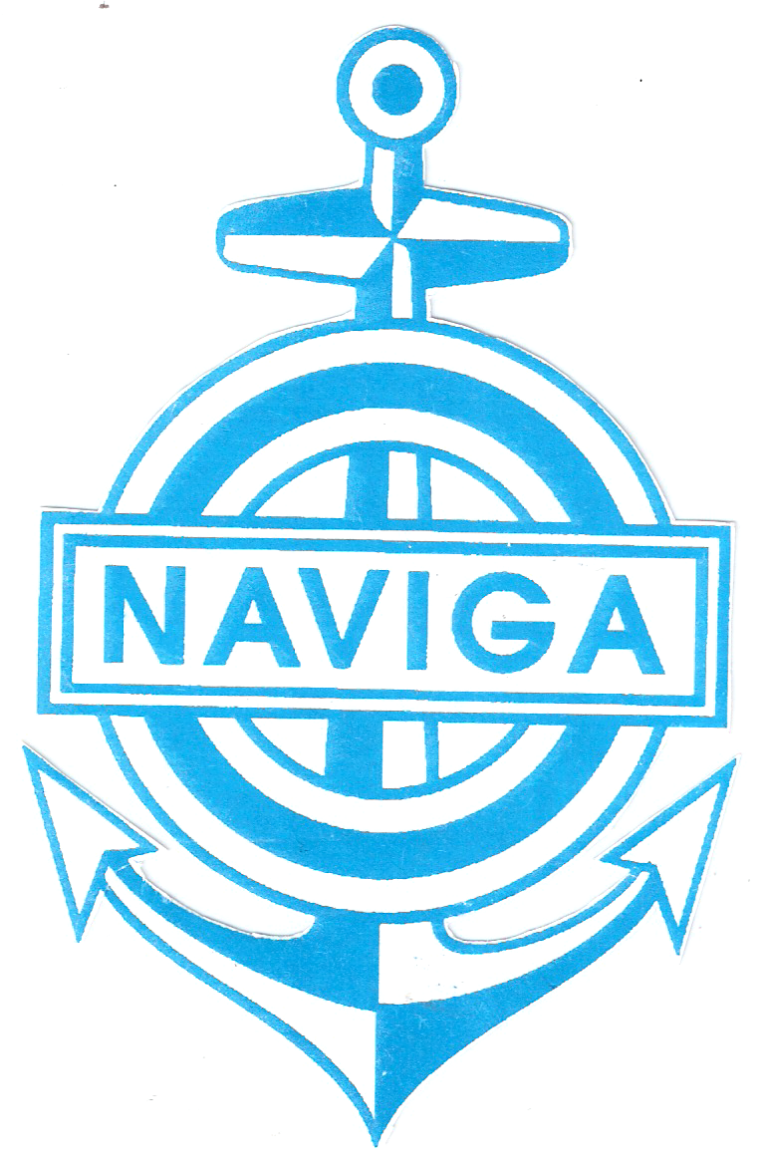World Organisation for Modelshipbulding and Modelshipsport NAVIGA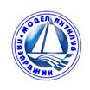
Bulgarian Ships Model Sport Federation
Pazardzhik Model Yacht Club

REGULATIONS
For participation in the Youth Model ship World Cup
for radio controlled model boats – class M
from 21/07 until 26/07/2019 in the town of Pazardzhik, The Republic of Bulgaria

Organiser  Co-organiser | World Organisation for Modelshipbuiling and Modelshipsport NAVIGA  Bulgarian Ships Model Sport Federation  TENSHOK
Contractor | Pazardzhik Model Yacht Club  Competition Equipment supplier: TENSHOCK
Location | The Republic of Bulgaria, the town of Pazardzhik, Ostrov Svoboda Park  （GPS: 42°10'53.1"N /24°20'04.6"E）
Time | from 21/07 until 26/07/2019
Main Judge | Maciej Kozłowski - Poland
Technical Director | Dimitar Ganchev - Bulgaria
Rules | NAVIGA – 2018
Classes | Mini Eco, Mini Eco Team, Mini Mono, F4-A, F5-550
 | Competitors can only participate in the Mini Eco and Mini Eco Team classes as the same models are used. After accepting the final queries, the organizers will also determine the quota for the number of competitors in each class and group.
Age groups | Youths up to 12 years - U12, born before 21/07/2007  Youths up to 18 years - U18, born before 21/07/2001
Additional requirements | - The organisers shall provide full equipment, including: boat set, parts, motor, ESC, radio, battery and charger. Additional parts can be bought during the competition. The competitors are not allowed to use other parts or equipment, except for the provided radio parts. The teachers/coaches are allowed to instruct the competitors how to build the models. It is forbidden for them to build the models.  - When registering, the team leaders have to give the organiser 3 /three/ national flags with the size of 1/1,5 m and a recording of the national anthem.
Deadline for  receiving  participation  applications | 05/05/2019  Please, in addition to your electronic application, send a hard copy.
Confirmation from  Organiser of  applications received | The Contractor shall confirm receipt of application within 5 days on  the e-mail address, specified by the Applicant..
Registration contacts | - Additional information on registration: registwym2019@gmail.com, Kalina Zaharieva  - Information: registwym2019@gmail.com, Ivan Zahariev
Registration | - 08:30 – 11:00 a.m. on 21/07/2019 in Pazardzhik Model Yacht Club, Ostrov Svoboda Park
Technical Conference | On 21/07/2019 at 11:00 a.m. in Pazardzhik Model Yacht Club
Prizes | - Top eight competitors in U12 and U18 shall be awarded individual prizes  - The team prize is determined by the best results of the three top competitors from each country. The team with the lowest total number of points is at first place. Points: 1st place - 0 points, 2nd place - 1,7 pts., 3rd place - 3 pts., 4th place - 4 pts.………… 11th place - 11 pts.  - For class Mini Eco Team there will be no team prize.
Participation fees | 80 Euros, for class Mini Eco Team - 10 Euros per competitor
 | Please, send the fees for participation, hotel reservations and the cocktail party beforehand to the enclosed account
Protesting fee | 20 Euro
Addresses for sending applications and hotel reservations | – to e-mail: myachtklub@bfkks.com  Postal address: Bulgaria, Pazardzhik 4400, 3 Gradinarska Str.,  Dimitar Ganchev, tel:.+35934463348, GSM+359878995621
Cocktail party | On 25/07/2019 г. at 08:00 p.m., price - 20 Euro for competitors, team leaders and accompanying persons.
Bank account in  Euro for transferring  the participation fees | UNITED BULGARIAN BANK  IBAN: BG77UBBS80021452084410 - EUR  BIC Code: UBBS BGSF  MODEL YACHT CLUB – PAZARDZHIK, BULGTARIA
Accommodation | *** Trakiya Hotel, Tel.: +35934466006, E-mail: trakijaburo@abv.bg. www.Hotel-Trakia.domino.bg  - Single room: 25 Euro  - Double room: 35 Euro  - Suite: 45 Euro  **** Hebar Hotel, Tel.: +35934990000, E-mail: reservation@grandhotelhebar.net, www.grandhotelhebar.net  - Single room: 40 Euro  - Double room: 55 Euro  - Suite: 90 Euro /for three people/  The price includes breakfast, parking, insurance, internet  /There will also be a camping site in the area of the competition!!!/  /There will be catering for lunch at the test areas/
Deadline for application updating | 05/07/2019

Pazardzhik Model Yacht Club
President:
/D. Ganchev/

REGISTRATION FORM:

Country:
Leader Name:
Contact /email, tel./
Name | Nationality | Sex | Date of birth -U12 | Class | MYLAPS No. | Size of T-shirt | Entry fee
Name | Nationality | Sex | Date of birth -U18 | Class | MYLAPS No. | Size of T-shirt | Entry fee

Mini-EcoTeam Registration:
Name | Country No. | MYLAPS No. | Entry fee

SCHEDULE:
JULY | 21st | 22nd | 23rd | 24th | 25th | 26th
MORNING | Opening  Building/Adjusting boats | Building/Adjusting | Building/Adjusting | Trial match | Trial match | Final
AFTERNOON | Building/Adjusting boats | Building/Adjusting boats | Building/Adjusting boats | Trial match | Trial match | Awarding and closing ceremony

Information about travelling to Pazardzhik and hotel accommodation:
Possible date and time of arrival and departure:
- by car: …………..
- by train:…………..
- by plane:…………………

1. We would like to book rooms at hotels for the following dates:
Hotel | Room with beds | Number of rooms | Price per room in € | 20.07 | 21.07 | 22.07 | 23.07 | 24.07 | 25.07 | 26.07

