



Invitation
World Championship 2019
Section M
ITALY

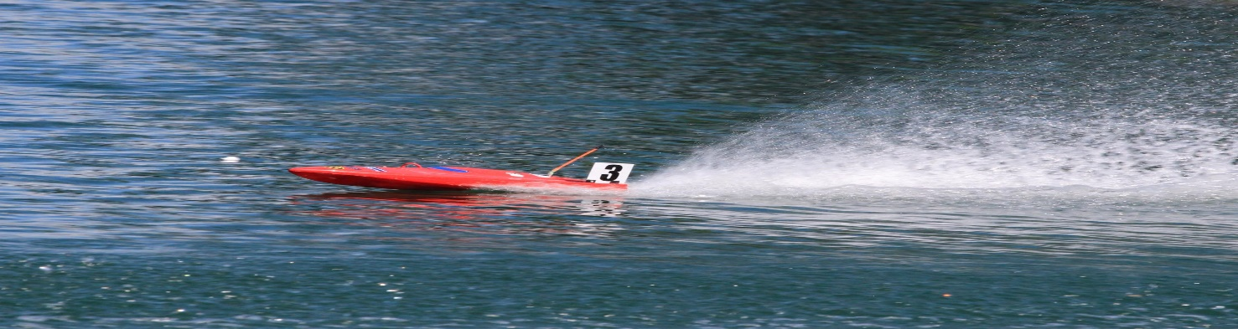
Organizer: Naviga, World organization for model ship building
Executor: Powerboat Italian Federation (FIM) for Club Motonautica
Radiocomandata Chioggia (CMRC)

Place: Lago Le Bandie Spresiano ITALY 45°44’46”N 12°17’0”E
Date: From 1 august to 10 august 2019
Classes: F1E; F3E; F3V; F1V; 3,5; F1V15;
Mini Eco; Eco Expert; Mini Eco Team; Eco Expert Team FSR E;
Mini Hydro; Hydro1; Hydro2;
Mini Mono; Mono1; Mono2;

Each for juniors and senior
Dead line for inscription: 2019/06/01
Entry Fees: Juniors 20 Euro per Class
Seniors 40 Euro per Class
Team Juniors 30 Euro per Team
Team Seniors 60 Euro per Team

Registration: The registration must be made on the web page of the
italian Federation (www.fimconi.it) in the races section. Once completed and sent it must be printed and sent by mail to: a.cremona@fimconi.it

E-mail: a.cremona@fimconi.it
Bank payment: IT27D0200820901000105475401
Rules: Naviga Rule 2019
Main Judge: Geens Walter
Protest fee: 20 Euro (as pr Naviga Presiduim Solved)
Frequencies: 40 Mhz Bands and 2,4 Ghz
Frequencies Classes: F1V: 40 Mhz Ch 50,52
F1E: 40 Mhz Ch 54,56
F3: 40 Mhz Ch 52,53
Eco, Mono/Hydro and FSR E classes:
All channels from the above frequencies bands, including
2,4 Ghz for all classes.

Fuel: Nitrometane limited to 25 vol %
Medal and certificates: The first threee placed partecipants in each class will be
awarded a medal and certificate. All ether partecipants
received a cerificate of partecipation.

Flags and national anthem: Each partecipating nation is obbligated to provide 3 flags
(150X100Cm), and CD or USB stick with the national
anthem. After the closing ceremony on 10 august the flags
and CD/USB will be returned to the respective delegation
leaders.

Banket: For partecipants, judges, organizing committe and simpathizer at
the price of 40 Euro each person. It is mandatory to subscribe
for partecipation on the banquet by completing the subscription
form.

Round count: Mylaps rc4/ea: 00-04-d7-04-22-60 counting via mylaps transponder ( Mrt
and other copies not work)

Transfert device: the transfert service from/to Venice or Treviso Airports International will
be possible on request. Please fill the corrispondent field in the entry
form.

Hotel and accomodations: Hotel Thai Si;
Hotel Spresiano;
Le Terrazze Hotel residence;
More info on www.navigawc2019italia.it
Camping at lakeside.

Restoration: restaurant and buffets at lakeside.

More info: www.navigawc2019italia.it

