World Organisation for Modelshipbulding and Modelshipspoirt NAVIGA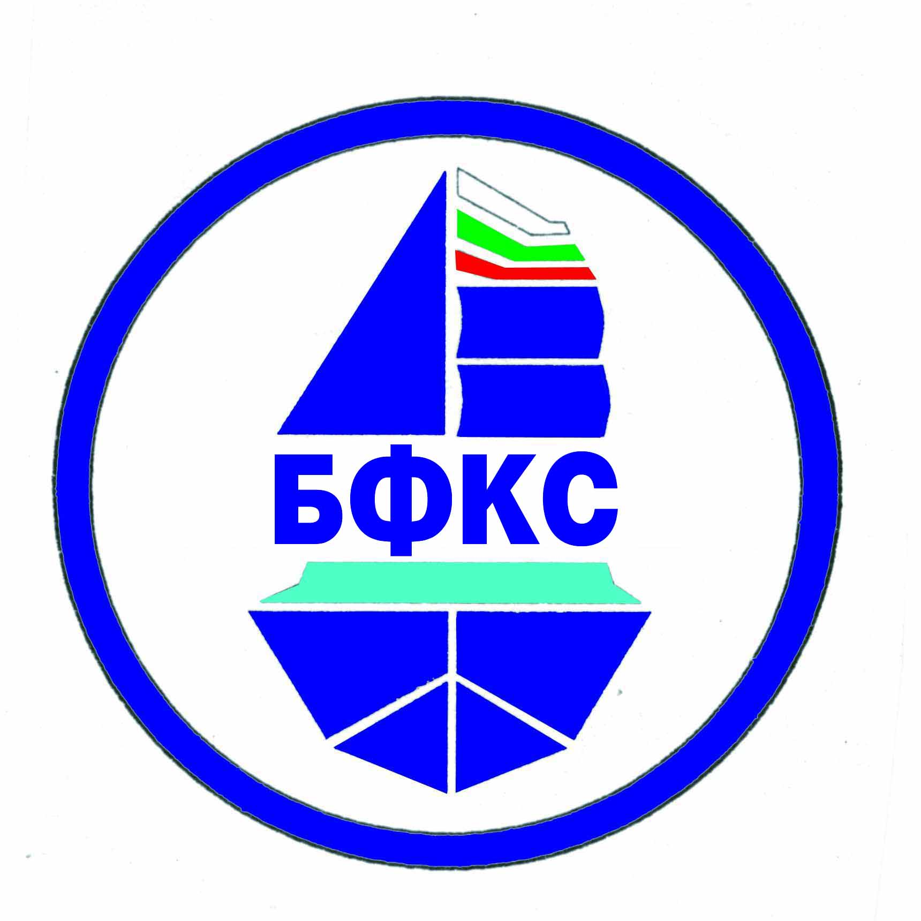
Bulgarian Federation of Modelsipsport

REGULATIONS
For Participation in the 20th European Championship of Modelshipsport for Speed Modelships – Classes A/B
From 23 July to 29 July 2018 in the town of Pazardzhik, the Republic of Bulgaria

Organizer | World Organisation for Modelshipbuilding and Modelshipsport NAVIGA  Bulgarian Federation of Modelshipsport  Municipality Pazardzhik
Executor | Bulgarian Federation of Modelshipsport  Model Yacht Club - Pazardzhik
Place | “Liberty Island” Park, the town of Pazardzhik, the Republic of Bulgaria
Time of Holding | From 23.07.2018 to 29.07.2018
Chief Justice | Svetlomir Sandev- BUL
Representative of NAVIGA | Hrachya Shahazizyan – Leader of Section A/B – NAVIGA
Technical Director | Dimitar Ganchev  E-mail: myachtklub@bfkks.com
Chief Secretary | Larysa Paskhalova - UKR
Rules | NAVIGA – 01.01.2014
Classes | A1, A2, A3, B1, A1E, B1E
Allowed number of models from a national federation | Each country has the right of 10 participants in a class, plus the European champion from 2018. After accepting the applications, there must be at least 10 participants in each class of the senior and 6 participants of the junior. The juniors must not be older than 18 in 2018.
Age Groups | Man and youths
Other Requirements | - Judges are not allowed to participate as competitors.  - By 03.07.2018 the Executor will inform all teams about the number of the registered competitors in each class and about in which classes there will be starts held valid for classification for the European Championship. In classes where there are fewer competitors than 10 for the senior and fewer than 6 for the junior the title European Champion will not be awarded.  - At registration, the leader of the teams have to provide the organizer with 3 / three/ national flags in the size of 1/1.50 m and the national anthem recorded on a compact disk or a flash memory.  - The competitors in E classes have to provide the range of their radio appliances and the numbers of the quartzes, without any 2.4 MHz /DSM/.
Deadline for receiving applications | 14.06.2018  We would like you to send as your application both electronically and on paper.
Confirmation of received application by the executor | The executor will confirm each application within 5 days at an e-mail mentioned by the applicant. We would like you to provide us with fax number or postal address if you do not have an e-mail.
Latest possible date for arrival | 24.07.2018

Registration | From 13:30 to 18:30 on 23.07.2018and from 09:00 to 12:00 on 24.07.2018 at Model Yacht Club – Pazardzhik, “Liberty Island” Park
Technical Conference | On 24.07.2018 at 13:30 at Model Yacht Club – Pazardzhik
Medals, Honorary Diplomas and Other Prizes | - Medals and honorary diplomas; Diplomas for all  - “Georgi Mirov” Bowl for class A1, “Filip Stefanov” Bowl for class A2, “Vladislav Subotin” Bowl for class A3, “Radi Radev” Bowl for class B1, „Lazar Lazarov” of updates in classes A / B
Initial Fees | For Seniors – 30 Euro, Juniors – 20 Euro /+3 Euro – insurance/
Price of Fuel | For A1, B1 – 2 Euro, A2 – 3 Euro, A3 – 5 Euro ,B1E,A1E-2Euro  Please, send the fees for participation, booking the hotel and for the reception in advance to the enclosed bank account.
Fee for Protests | 20 Euro
Addresses for Sending the Applications | By 13.06.2018 – at E-mail: panajotov@bfkks.com  Postal address: Recipient: Kolya Panayotov, 211, Krasno Selo Housing Estate, Entrance 2, flat 32, the city of Sofia 1618, Bulgaria  Tel.: +3598564147, Mobile phone: +359888227837  From 14.06.2018 – at E-mail: myachtklub@bfkks.com  Postal address: Recipient: Dimitar Ganchev,3, Gradinarska Street, the town of Pazardzhik 4400, Bulgaria  Tel.: +35934463348, Mobile phone: +359878995621
Banquet | On 27.07.2018 at 20:00, a price of 20 Euro for competitors, leaders of teams and accompanying people.
Bank Account in Euro for sending the initial fees, the fees for fuel and the reception. | IBAN: BG13STSA93000011368935 in Euro  BIC Code: STSABGSF  Dsk Bank AD, 5, Dondukov Boulevard, 1000 Sofia, Bulgaria  Bulgarian Federation of Modelshipsport
Accommodation and Food | *** Trakiya Hotel, Tel.: +35934446006, E-mail: trakijaburo@abv.bg. www.Hotel-Trakia.domino.bg  - Single room: 20 Euro  - Double room: 30 Euro, - Suite: 40 Euro,  **** Hebar Hotel, Tel.: +35934990000, E-mail: reservation@grandhotelhebar.net, www.grandhotelhebar.net  - Single room: 35 Euro  - Double room: 50 Euro  - Suite: 80 Euro /for three people/  The prides includes breakfast, parking, insurance, internet  The transport from Sofia Airport to the town of Pazardzhik is possible to be organized if there is a request and order in advance from your side.
Deadline for updating your booking with regard to the accommodation: | 14.07.2018

Bulgarian Federation of Modelshipsport Model Yacht Club – Pazardzhik
Chairman: Chairman:
/E. Genov/ /D. Ganchev/

