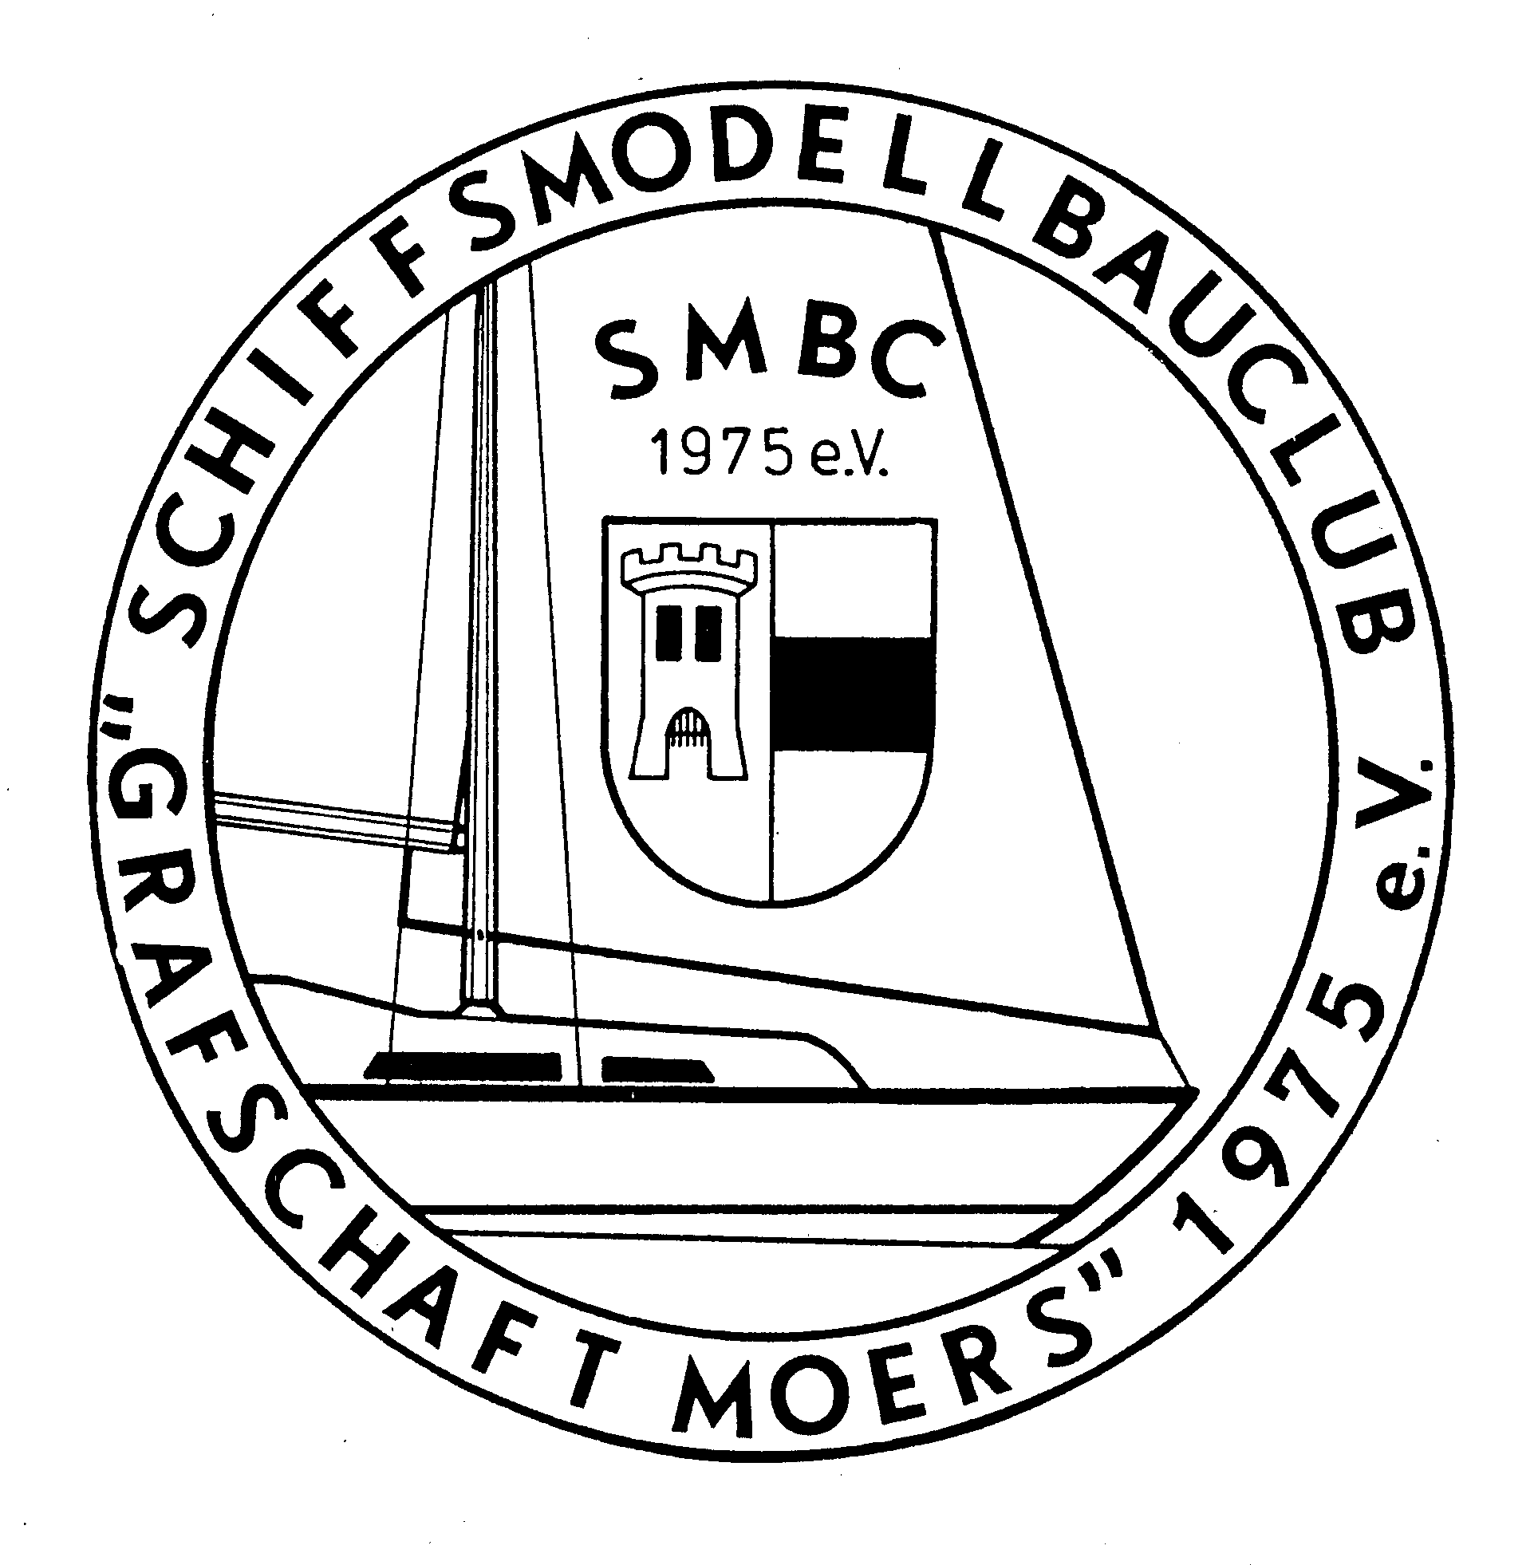

Schiffsmodellbauclub
„Grafschaft Moers“
1975 e. V.
SMBC „Grafschaft Moers“ Postfach 2208 , 47412 Moers

Bankverbindung Sparkasse Moers
IBAN:DE11354500001101081113
BIC: WELADED1MOR

Moers, den 06.02,2018

Invitation to International Racemeeting for electro boats

11.05.-13.05.2018

We invite all electro boat racers to our Intenational race in Moers.
Everyone who has a boat comform the M class Rules can participate.
There are a few particularities to be observed on our grounds
1. After the lunchbreak there is a 15 minute free practise, before and after the race there is no training allowed
2. We must have a lunch break. During that period there is absolutely no training. Should anyone ignore this, an immediate disqualification will be the result.
- We have to consider the neighbourhood, therefore we have to keep the noise level down, any unnecessary noise is to be avoided, especially evenings and nights!

Federation : Nauticus
Organising club : SMBC- Moers
Adress : Germany, 47447 Moers (in the Ruhr area, near Duisburg and Düsseldorf, Province Nordrheinwestfalen) village of Schwafheim Moers, Altdorferstrasse (a set of direction is included) follow the shields SMBC.
Date :11.05.-13.05.2018

Classes : Eco-Expert, Eco-Standard, F3E, Mini Eco, FSRE
Hydro I& II, Hydro AS.Mini Hydro, Mono I & 2, MS1 & 2, Hs1& 2, Mono AS,Mono BS, Mono M 400
(Eco-ex, Eco std,F3E,Mini Eco, FSRE will count during the event as qualification races for Nauticus

Enrolment : SMBC Moers, Rembrandtstrasse 17, 47447 Moers
Fax: 02841 8823429 ( only by letter) E mail:
MichaelDahm@t-online.de
T
Transponder : Please include transpondernumber(s). If needed some transponders can be rented. 5€ rent per transponder. (in case of loss the full value is to be payed)
End of enrolment : 07.05.2018 (Postmark) Late entries or changes are possible to a degree on the day
Participant nbrs : Minimum 5 participants per class. If lower then some classes will be merged e.g HS1 and 2
Registration : 10.05.2018 from 12h till 16h, on 11.05.2018 from 7.30h till 8.45h at the info stand

Fees : Seniors 15€ per class, Juniors 7.50€ per class
Payable to: SMBC Moers, Sparkasse Moers. Acountnbr 110081113 BLZ 35450000, IBAN: DE113545000011010811113 SWIFT-BIC: WELADED1MOR
Rules : Naviga Rules 2017, no finals
Lapcounting : AMB transponder system
Catering : On the grounds
Lodgings : Camping is (limited) possible at 10€ per person.
Hotels nearby can be found at www.Moers.de
Please also look at youth hostels.

Miscellaneous : Bring shelter, chairs and tables. Power is available. The race coarse has pool noodles for buoys. Info on Rules: www.nauticus-info.de, www.naviga.org

We wish you a safe journey and succes at the race

The SMBC Moers club

Directions:
A40 comming from Autobahnkreuz Kaiserberg direction Venlo, exit Moers zentrum. Right at exit. Right again at next red lights, at second red lights (without pedastrian lights) take a left. 4 th street on the left, then second left till the end.

