
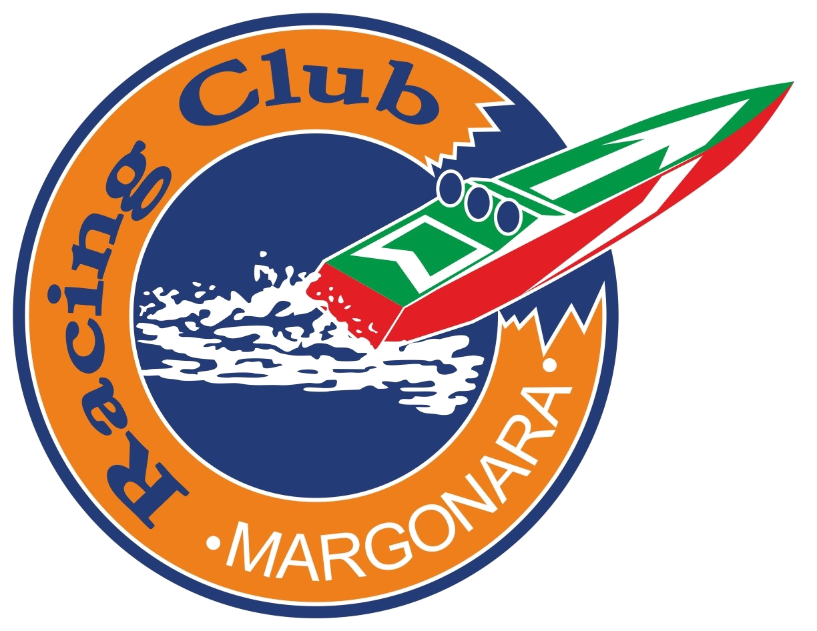
ITALIAN
FEDERATION
NAVIMODEL

FRIENDLY INTERNATIONAL RACE (OPEN)

1° City of Gonzaga Trophy

Promotive: FEDERAZIONE ITALIANA NAVIMODEL

Organizing Commitee: RACING CLUB MARGONARA

Place: Strada Ronchi, 99 - 46023 GONZAGA (MN)
Satellite Coordinates: 44° 56’ 45.27”N – 10° 46’ 51.02”E

Data: 12/15 July 2018

Entries: Deadline 30 June2018 send to:
m.wilmer@alice.it - rcm.laghimargonara.gmail.com

Each competitor will receive an immediate confirmation by e-mail of the event
registration and only then can be considered as a member .

Starting fee: 20 € Euro for each category
The registration fees must be paid in advance by bank transfer to this

IBAN: IT 24F 080015760000000320046

Classes: Eco Expert - Mono 1/2 - Hydro 1/2
Mini Eco - Mini Mono - Hydro

Results: Two best results on three heat

Rules: NAVIGA e NAVIMODEL

All the classes (no Eco) will use the same oval circuit of 150 mt.

IMPORTANT: All models must have a number plate white squar e (8 x 8 cm) and the
transponder AMB. Pain of exclusion to the start

Battery weight for Mini Eco and Mini Mono / Hydro 113 gr.

Hull length: Mini Eco cm. 43; Mini Mono / Hydro cm. 45

Attention : In this race the Italian pilots can use the Navimodel 2018 rules.

In alternative of two new Naviga LiPo options (standard 280 gr. and 30 mm. cable length

or energy limiter with no weight limit) is possible to use the Navimodel 2018 rules :

LiPo pack for 3S and 6S with a maximum of capacity of 5000 mAh, free weight.

LiPo pack for 2S and 4S with a maximum of capacity of 8000 mAh, free weight.

All LiPo pack must be orginal as from the producer without any modifications.

The use of modified or not original LiPo pack imply the elimination from the race.

IMPORTANT : The use of LiPo Graphene or LiPo High Voltage are not allowed.

Conditions of participation:

Free training:

Recordings / check hulls:

Registrations:

Opening competitions:

Safety:

Services:

Camping:

How to reach the Margonara lakes:

Where stay:
BLUE HOTEL
Participation is open to all pilots in possession of models of the classes provided.

Thursday 12 July 2018 from 9,00 am to 7,00 pm

Circuit available on the whole day of Thursday 12 July 2018 after registration

Thursday all day

Friday 09.00 AM.

The competition is covered by insurance for damage to property and / or persons caused or suffered from the pilots

On site there are all the amenities: restaurant (much appreciated), bar with sandwiches, drinks, coffee, etc., etc., electricity, playground, etc., etc..

On site there is a space reserved for Campers, Caravans and Tents .

Take exit Reggiolo-Rolo on the A22 Brenner motorway, at the roundabout take the 2nd exit and continue along the bypass for about 4 km.. At the crossroads at the end of the road, turn right. Continue along this road towards Gonzaga, Mantova after about 1.5 km you will reach a crossroads, turn left into the "Road of Ronchi", after about 1,8 km, on the left you will see the sign of the Margonara lakes, turn left and continue along this road; the road ends in the parking of the lakes.

Via dell'Artigianato 5/d Strada Provinciale per Suzzara 46029 Suzzara (MN) Italy

Tel (+39) 0376 534615 Fax (+39) 0376 530202 www.blue-hotel.it E-mail info@blue-hotel.it

Garden Hotel Suzzara Via Ippolito Nievo 16A 46029 Suzzara (MN) Italy
Tel: (+39) 0376 533666 Fax: (+39) 0376 532074
www.gardenhotelsuzzara.it E-mail: info@gardenhotelsuzzara.it

ZARA rooms & suites Piazza Garibaldi Giuseppe 4/F - 46029 Suzzara (MN) Italy
Tel: (+39) 0376 536317 - (+39) 3881822771
www.zarasuzzara.it - info@zarasuzzara.it

Agriturismo Boschi Via Cattanea, 54 - 42046 Reggiolo (RE)
Tel: (+39) 0522 972745 - (+39) 3357891657
agri.boschi@email.it - Agriturismo Boschi on Facebook

Albergo Villa Montanarini Via Mandelli, 29 - 42045 Villarotta di Luzzara (RE)
Tel: (+39) 0522 820001 - Fax: (+39) 0522 820338
www.villamontanarini.com - info@villamontanarini.com

Agriturismo Corte Giardino Via Tomba, 29 - 42045 Luzzara (RE)
Tel: 0522.223373 Fax: 0522.223373
info@cortegiardino.it - www.cortegiardino.it

Ostello Ca'maleonte Via del Parco, 1 - 42023 Palidano di Gonzaga (MN)
Tel: 0376.508370 - 335.5292604 -320.1555491
ostello@centrocamaleonte.it - www.centrocamaleonte.it

ENTRY FORM

1° City of Gonzaga Trophy

Margonara lakes (Gonzaga) - 12/15 July 2018

Name-Surname: ………………………………………………………………….

Address: ……………………………………………………………………………

Nation: …………………………………………………………………………….

Bank Transfer number : ……………………………………... Date: …………………

 |  | Frequencies (o 2.4 Ghz) |  | Transponder Number
Mono 1 | ……….. | ………… ……….. | ……….. | ………………………
Mono 2 | ……….. | ………… ……….. | ……….. | ………………………
Hydro 1 | ……….. | ………… ……….. | ……….. | ………………………
Hydro 2 | ……….. | ………… ……….. | ……….. | ……………………....
Eco Expert | ……….. | ………… ……….. | ……….. | ……………………....

Send to: m.wilmer@alice.it - rcm.laghimargonara@gmail.com

